Title and subtitle

Title and subtitle

Overview of the Project 2

Business Architecture Diagram 3

Requirements as User Stories 4

Architecture Diagram depicting the 5

Test Strategy 6

Deployment Architecture of the application 7

# Overview of the Project

**Problem:**

* **Overflooded college-specific communication channels:** Existing social media platforms cater to a general audience, making it difficult for college students, faculty, and staff to connect and share information relevant to their college community.
* **Information silos:** Important college-related announcements, events, and discussions might be scattered across various platforms (e.g., email, student organization pages), making it challenging for users to stay informed.
* **Lack of engagement:** Traditional communication methods like email can be impersonal and have low engagement.

**Data-driven Approach:**

This project will leverage data to:

* **Connect users:** The system will utilize college affiliations (e.g., email addresses) during registration to connect users within the same college community.
* **Targeted information sharing:** Students can follow specific departments, clubs, or professors to receive relevant updates and announcements.
* **Content discovery and trends:** By analyzing user activity and interests, the system can recommend relevant content and highlight trending topics within the college community.
* **Improved communication and feedback:** The platform will facilitate real-time communication between students, faculty, and staff, fostering a more engaged college experience.

**Benefits for Users:**

* **Centralized communication hub:** Stay informed about college events, announcements, and discussions in one place.
* **Enhanced engagement:** Participate in discussions, share ideas, and get real-time updates.
* **Streamlined information access through Integration:** No more searching through multiple platforms for college-related information.
* **Improved sense of community:** Build a stronger connection with your college peers, faculty and even alumni.

**Social Media Integration:**

* Integrate with existing social media platforms to allow users to share content from the college platform to their wider social networks, potentially increasing reach and college awareness.
* Leverage existing social media logins for a more convenient user experience.
* Integrating social media platforms adds complexity and requires careful consideration of user privacy and data security.

# Business Architecture Diagram

**Business Need:**

REConnect aims to address the shortcomings of current communication methods within colleges and universities. These shortcomings include:

* **Scattered Information Flow:** Important announcements, updates, and resources are often disseminated through various channels (email, departmental websites, student organization pages), making it difficult for users to stay informed.
* **Inefficient Communication:** Distributed information across multiple platforms is exhausting to manage and resource-intensive.

**Current Process (as-is):**

* **Faculty/Staff:** Create announcements, updates, or resources.
* **Distribution:** Utilize various channels like email, whatsapp, instagram or physical posters throughout the campus.
* **Students:** Check various communication channels periodically for updates.
* **Engagement:** Interaction may be limited to infrequent email replies or passive information consumption.

**Business Problems:**

* **Inefficiencies:** Managing multiple communication channels becomes exhausting.
* **Information Gaps:** Students may miss crucial information due to scattered communication.
* **Poor Decision Making:** Lack of data on student engagement makes it difficult to improve communication strategies.

**Solution:**

REConnect provides a centralized platform for streamlined communication, fostering engagement and improving information accessibility. This translates to:

* **Increased Efficiency:** Streamlined communication channels save time and resources.
* **Enhanced Engagement:** Real-time interaction fosters a more connected community.
* **Improved Information Access:** Centralized platform ensures easy access to relevant updates.
* **Data-Driven Insights:** User data informs decisions to improve communication and campus life.

**Business Architecture Diagram:**

The business architecture diagram will consist of the following components:

* **User Personas:** Faculty/Staff, Students, Administrators
* **Business Functions:** Information Dissemination, Content Management, User Management
* **Business Processes:** Announcement Creation, Resource Sharing, Discussion Forums, Group Chats
* **Information Systems:** College Connect Platform, Existing College Systems (e.g., student information system)
* **Data & Analytics:** User Activity Data, Content Engagement Metrics

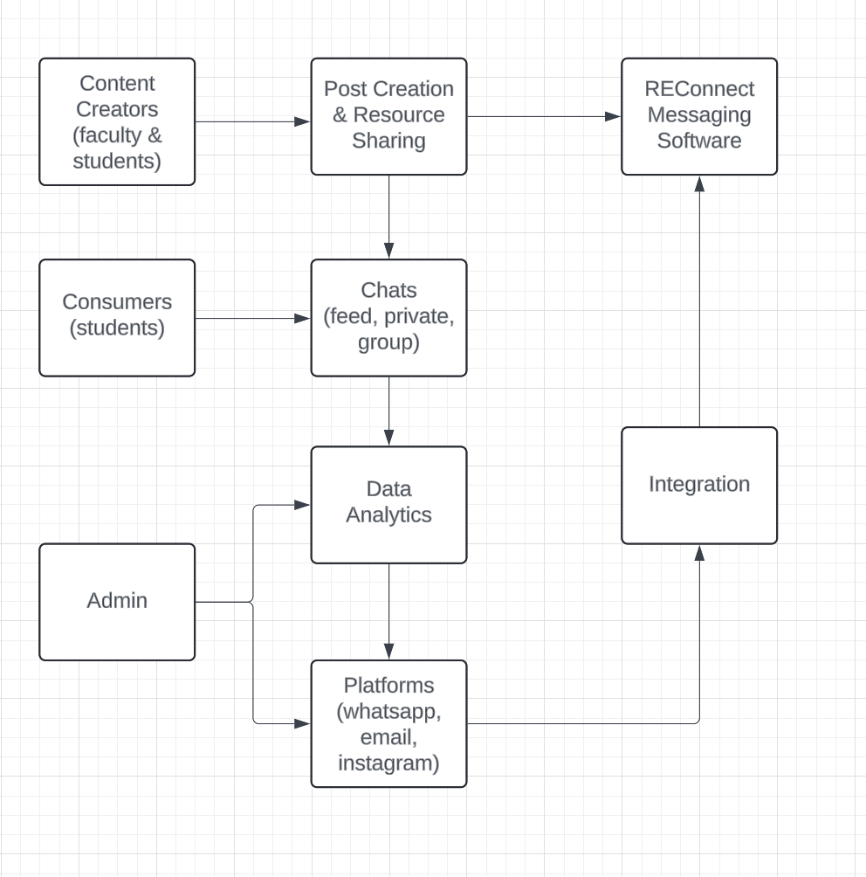

**Bussiness Architecture for REConnect Messaging System**

# Requirements as User Stories

* **User Story 1:** As a user, I want to see all my chats, individual chats, and group chats, so I can stay organized and keep track of my conversations. (This user story focuses on the ability to view a list of chats.)
* **User Story 2:** As a user, I want to prioritize important messages to be seen at the top so I can easily find and respond to the most important messages. (This user story focuses on the ability to prioritize messages.)
* **User Story 3:** As a user, I want buttons for jumping between the different pages (chats, contacts, settings, etc.) so I can easily navigate the application. (This user story focuses on the navigation of the application.)
* **User Story 4:** As a user, I want to post images and videos so I can share multimedia content with my contacts. (This user story focuses on the ability to send images and videos.)
* **User Story 5:** As a user, I want the UI to be easy to navigate through and all the functionalities to be easily accessible. (This user story focuses on the user interface and user experience of the application.)
* **User Story 6:** As a user, I want to have the buttons to jump to my profile and settings so I can manage my account information. (This user story focuses on the ability to access user profiles and settings.)
* **User Story 7:** As a user, I want the home page to have images and/or videos with the posts so I can see a quick preview of the content.
* **User Story 8:** As a user, I want to share my dept., section, etc. so that other users can find me and learn more about me.
* **User Story 9:** As a user, I want to find and connect with alumni to learn about their career paths and network for professional opportunities.
* **User Story 10:** As a user, it should be secure to prevent others from unauthorized access to my messages. (This user story focuses on the security of the application.)

**Non-Functional Requirements**

1. **Usability:**

* Friendly User-Interface
* Accessibility

1. **Maintainability:**

* Modular Design
* Documentation
* Robust

1. **Performance:**

* Scalability
* Response Time
* Availability

1. **Security:**

* Authentication and Authorization
* Data Security
* Profanity system to prevent inappropriate posts.

# Architecture Diagram depicting the

**Components:**

* **User Interface**
* **API Gateway:** TO integrate existing platforms
* **Business Logic Layer:** Handles core functionalities like announcement creation, resource management, and user interactions.
* **Data Access Layer:** Interacts with the database to store and retrieve data.
* **Database:** Stores all application data persistently (e.g., MySQL, MongoDB)
* **Notification Service:** Sends real-time customizable notifications about new announcements or messages.
* **Logging and Monitoring:** Logs application events, errors, and performance metrics for troubleshooting and analysis.

**Interactions:**

1. User interacts with the User Interface (Web/Mobile App).
2. User Interface sends requests to the API Gateway.
3. API Gateway authenticates/authorizes the request and routes it to the Business Logic Layer.
4. The Business Logic Layer processes the request, interacts with the Data Access Layer to access data, and generates a response.
5. API Gateway sends the response back to the User Interface.
6. Logging and Monitoring components capture relevant events throughout the process.

**Error Handling:**

* The API Gateway returns appropriate error messages in case of authentication failures or invalid requests.
* The Business Logic Layer handles business-specific errors and returns informative messages.
* All errors are logged for troubleshooting and analysis.

**Data Storage:**

* A relational database (e.g., MySQL, MongoDB) is used to store structured data like announcements, user profiles, and group information.

**Architecture Pattern: Microservices Architecture**

* REConnect utilizes a microservices architecture. The application is broken down into smaller, independent services (modules) that communicate through APIs.
* This approach offers several benefits:
  + **Scalability:** Individual services can be scaled independently based on their needs.
  + **Maintainability:** Easier to develop, test, and deploy changes in smaller services.
  + **Fault Tolerance:** Failure in one service doesn't necessarily impact the entire system.

**Design Principles:**

* **Separation of Concerns:** Each module focuses on a specific functionality, promoting modularity and maintainability.
* Services interact through single-entry APIs, minimizing dependencies, promoting scalability, and improving security.
* **Event-driven Architecture:** Can be implemented for real-time notifications, where services communicate through events.
* **Logging and Monitoring:** Crucial for troubleshooting, performance analysis, and debugging.
* Class diagrams

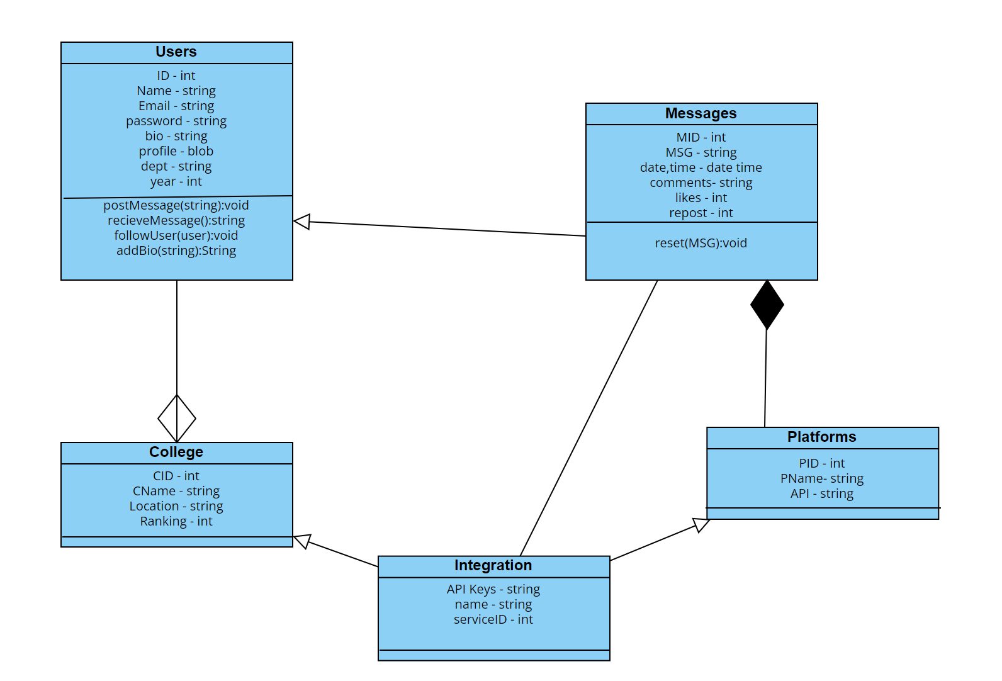

* Sequence diagram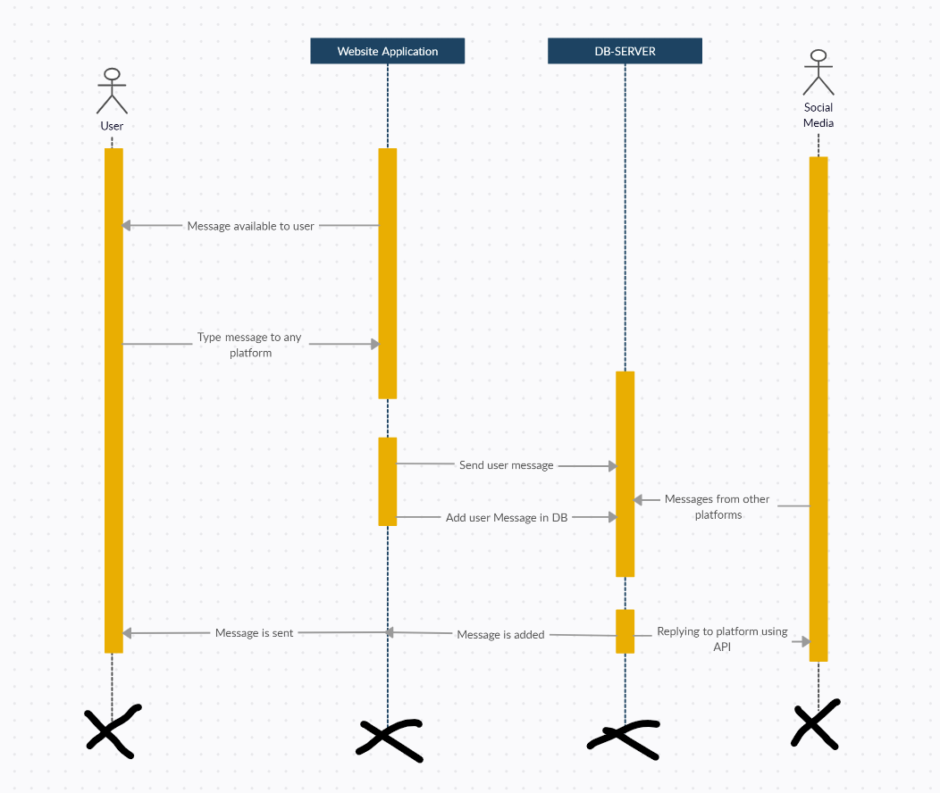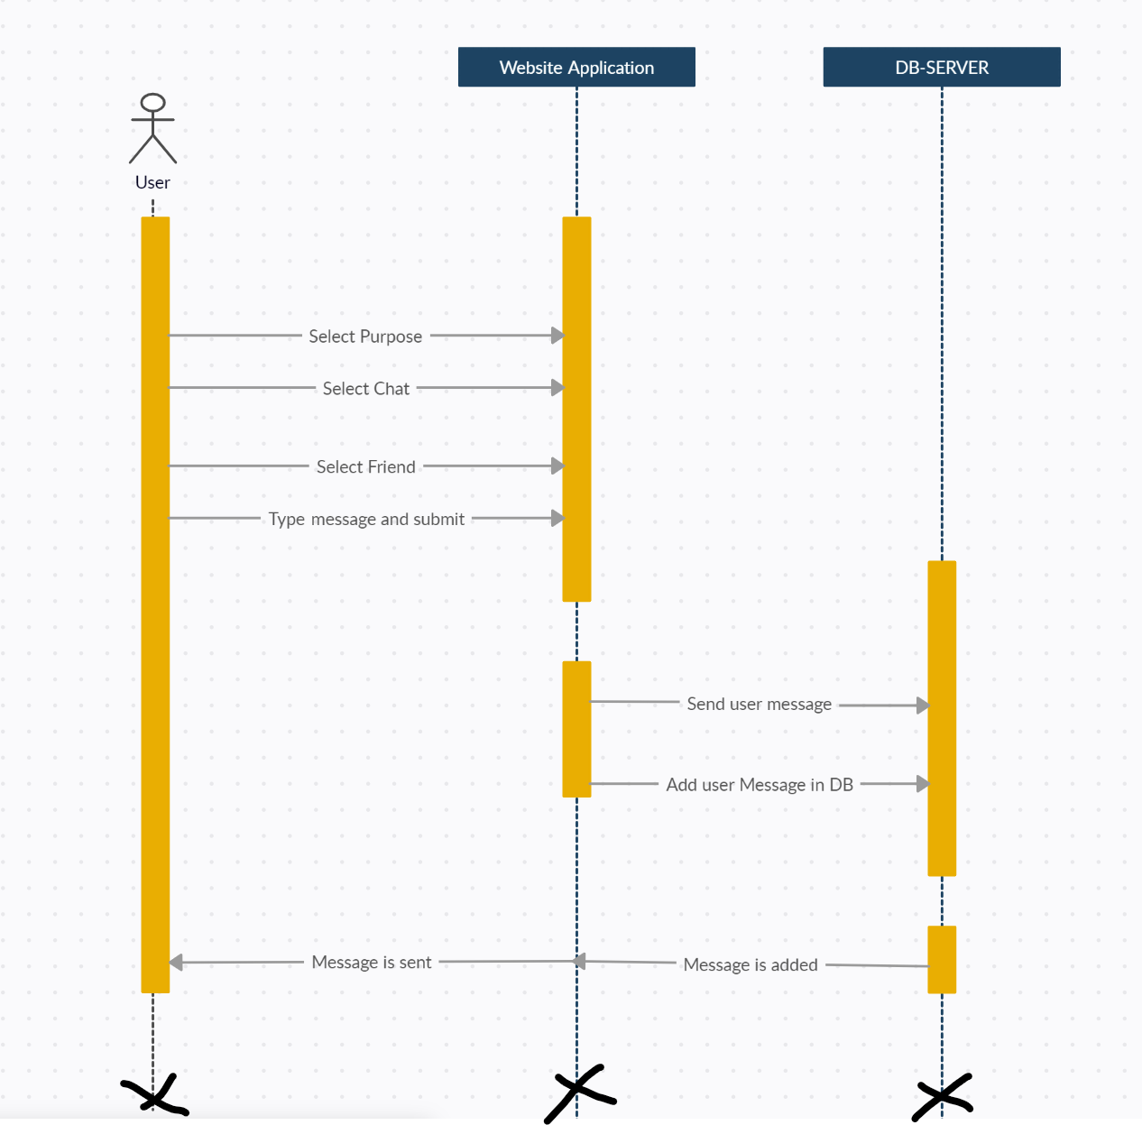

# Test Strategy

**User Story 1: As a student, I want to view a list of upcoming announcements to stay informed about important college events.**

**Test Cases:**

* **Happy Path:**
  + Login as a student user.
  + Verify a list of upcoming announcements is displayed.
  + Verify announcements are sorted by chronology.
* **Error Scenarios:**
  + Login with invalid credentials (incorrect username/password). (Expected behavior: Login error message)
  + Attempt to access announcements without logging in. (Expected behavior: Access denied message)
  + Verify the system gracefully handles situations where there are no upcoming announcements. (Expected behavior: Empty announcement list message)

**User Story 2: As a student, I want to join a club discussion forum to connect with other members and ask questions.**

**Test Cases:**

* **Happy Path:**
  + Login as a student user.
  + Navigate to the specific club discussion forum.
  + View a list of existing discussion threads.
  + Open a thread and view comments from other members.
  + Post a new comment within the thread to share your question.
* **Error Scenarios:**
  + Login with invalid credentials. (Expected behavior: Login error message)
  + Attempt to access a club forum without logging in. (Expected behavior: Access denied message)
  + Verify the system handles situations where a club doesn't exist or has no forum. (Expected behavior: Error message or empty forum display)
  + Try to post a comment exceeding the character limit. (Expected behavior: Character limit error message)

**User Story 3: As an administrator, I want to manage user accounts and ensure system security.**

**Test Cases:**

* **Happy Path:**
  + Login as an administrator.
  + Access the user management console.
  + View a list of all registered users with their roles (student, faculty, admin).
  + Deactivate a user account if necessary.
* **Error Scenarios:**
  + Login with invalid administrator credentials. (Expected behavior: Login error message)
  + Attempt to access user management without administrator privileges. (Expected behavior: Access denied message)
  + Verify the system prevents unauthorized attempts to modify administrator accounts. (Expected behavior: Access denied message)

**User Story 4: As a student, I want real-time custom notifications about new announcements and messages.**

**Test Cases:**

* **Happy Path:**
  + Login as a student user and enable push notifications in the app settings.
  + Verify the student receives a notification when a new announcement relevant to their interests is created (they can specify their interests by following certain accounts).
  + Verify the student receives a notification when they receive a new message within a discussion forum.
* **Error Scenarios:**
  + Login with invalid credentials. (Expected behavior: Login error message)
  + Verify notifications are not sent to users who haven't opted-in.
  + Verify the system gracefully handles situations where push notification delivery fails due to internet connectivity issues on the user's device. (Expected behavior: Notification delivery attempt with potential retry mechanism)

**User Story 5: As a user, I want the platform to integrate and display messages from other social media platforms with college presence.**

* **Happy Path:**

1. The user logs in to REConnect.
2. REConnect securely connects to the user's various messaging platforms (email, WhatsApp, Instagram, etc.) through authorized integrations.
3. Once connected, REConnect retrieves all unread and recent messages from the various platforms.
4. REConnect presents a unified view of all messages within its interface.
5. Users can filter messages by platform, sender, or keywords for easier management and organization.

**Error Scenarios:**

1. **Invalid Login Credentials**
2. **Connection Failure:** In case of temporary network issues or server outages during the connection, the user should receive a user-friendly message explaining the issue.
3. **API Permissions:** If the user's account on a specific platform lacks sufficient permissions to access messages, REConnect should inform the user about this limitation
4. **Security Concerns:** REConnect should prioritize user data security.

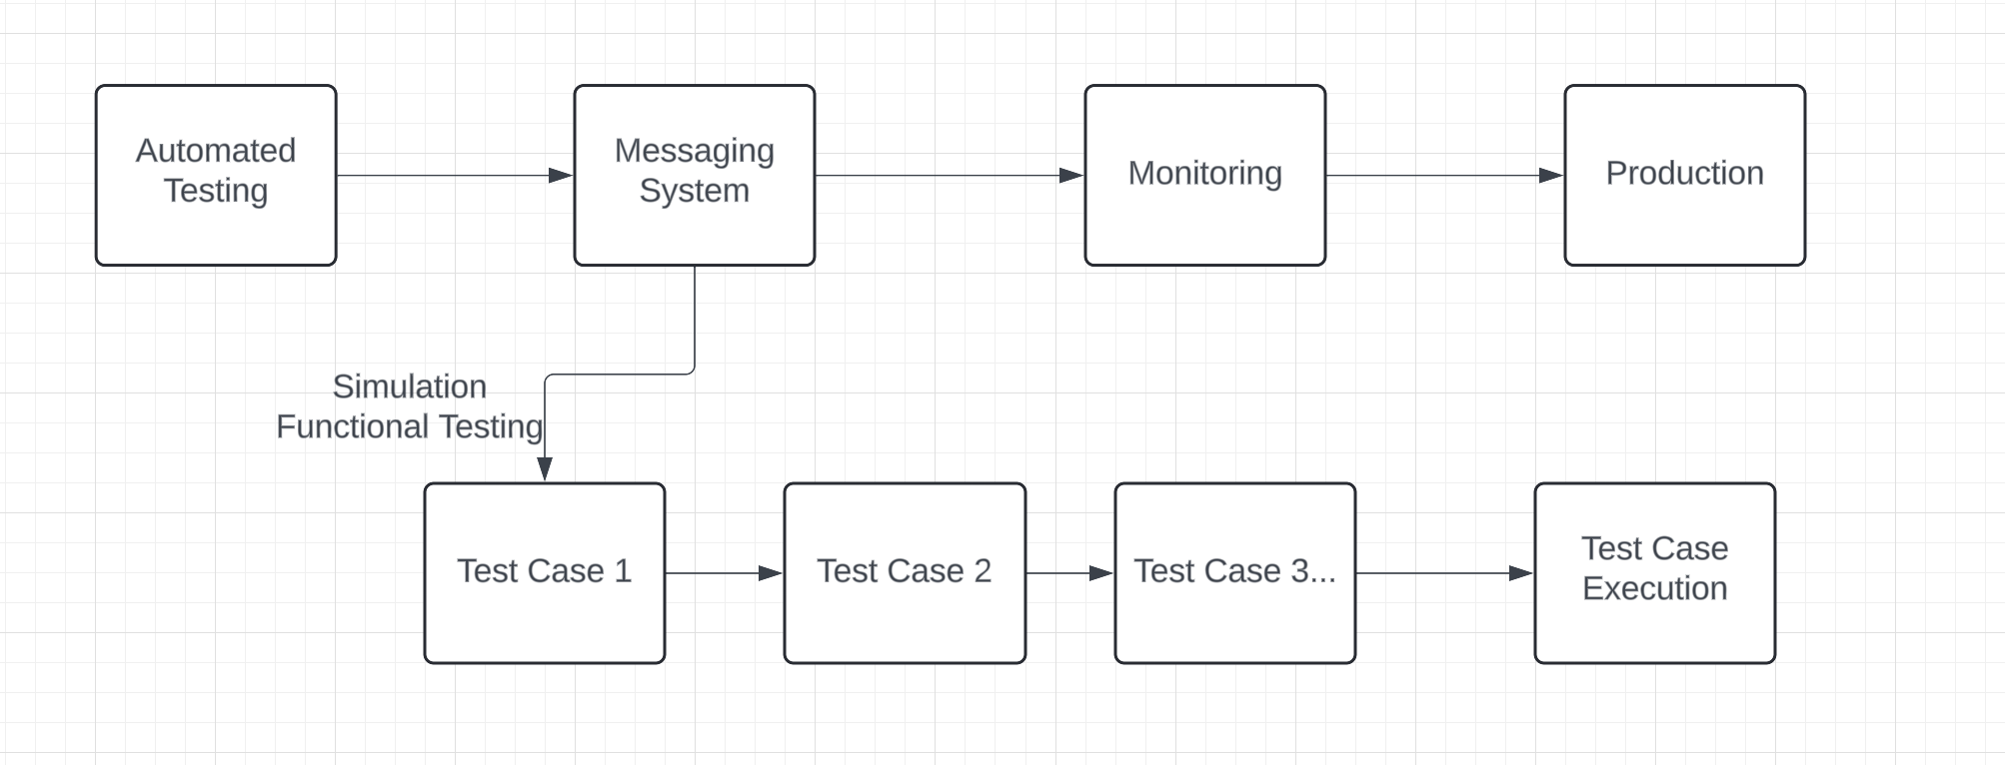

5. A view of the github repository showcasing the Project structure, their naming conventions

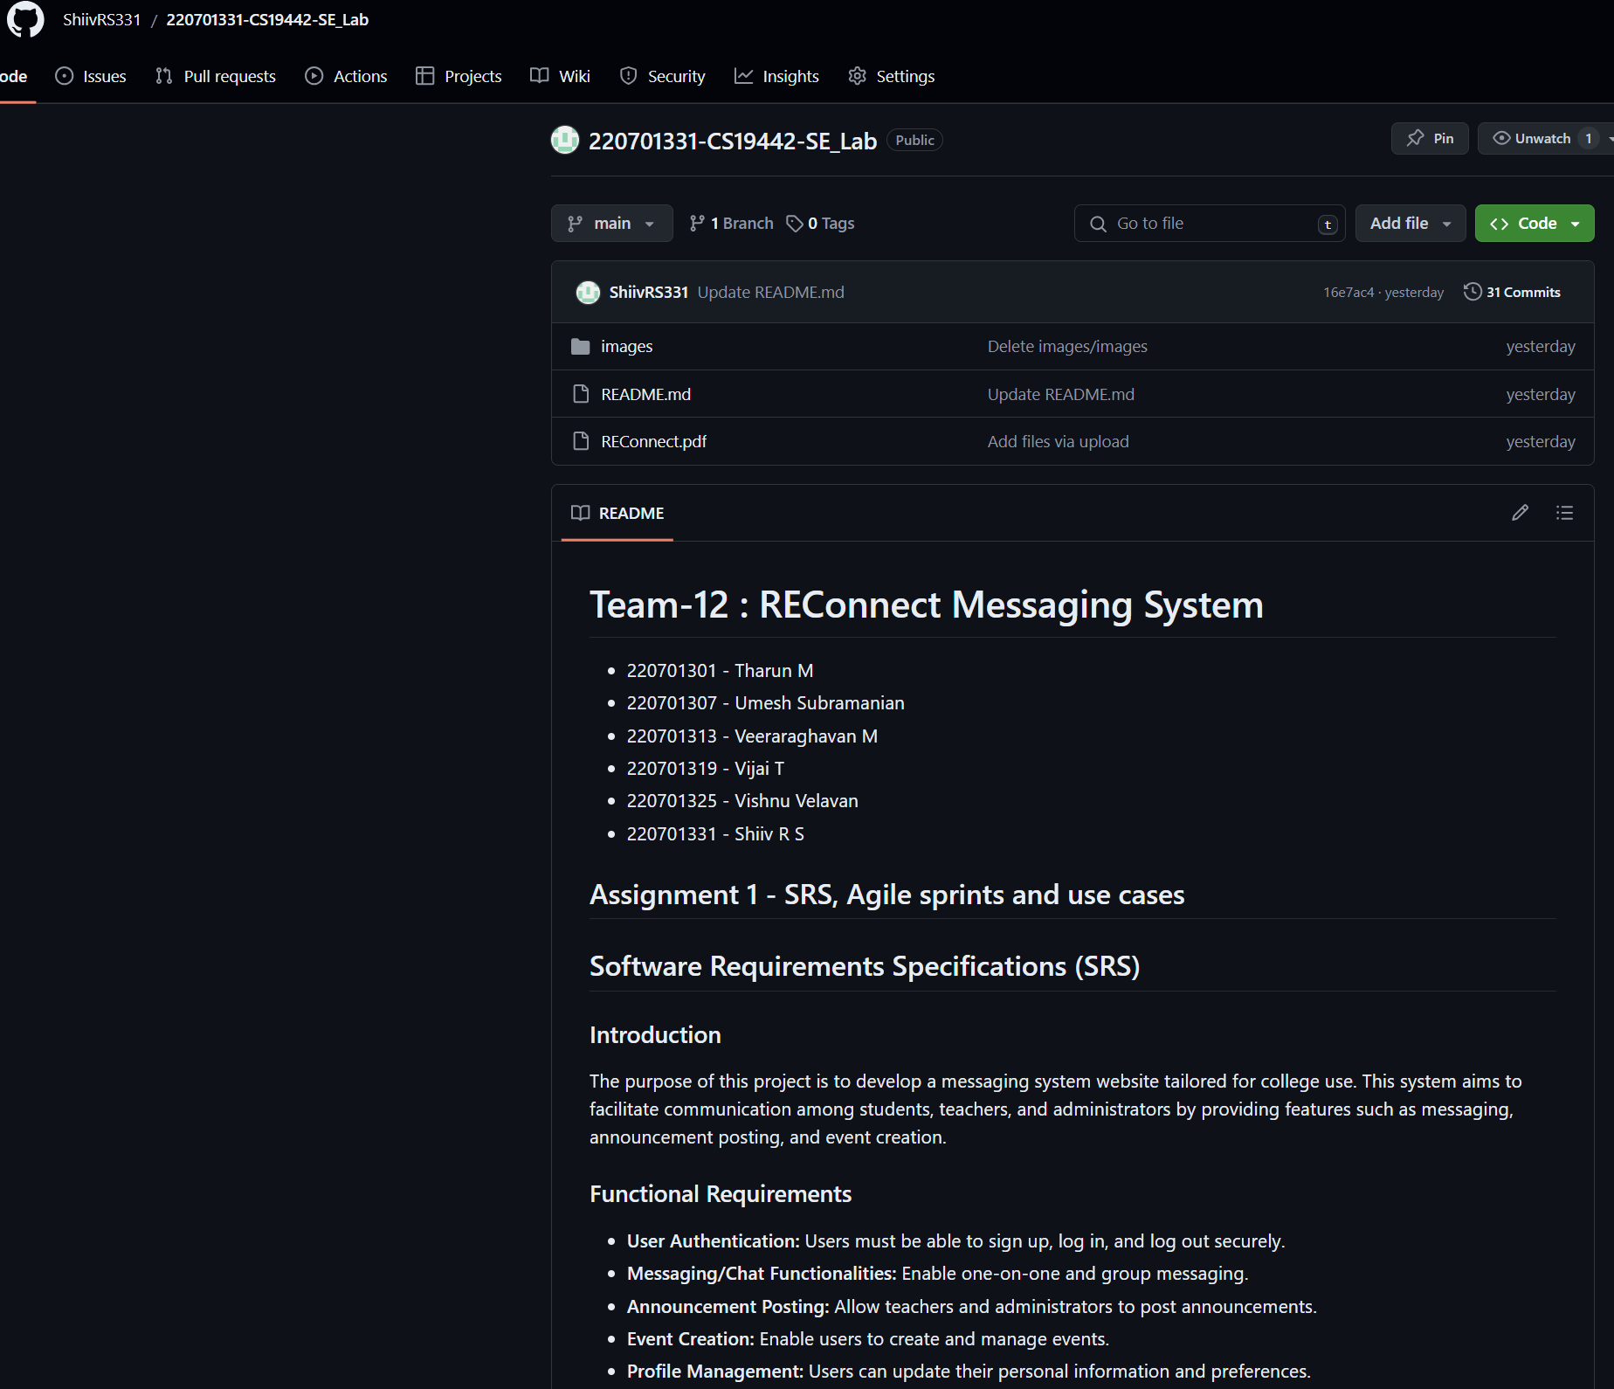

A view of their DevOps Architecture for their respective project and the associated tools used in Azure

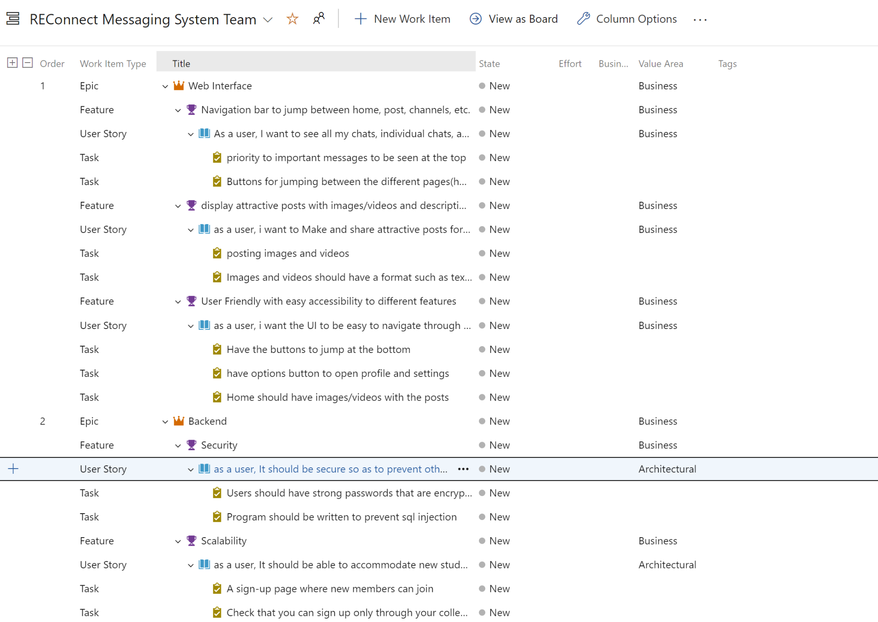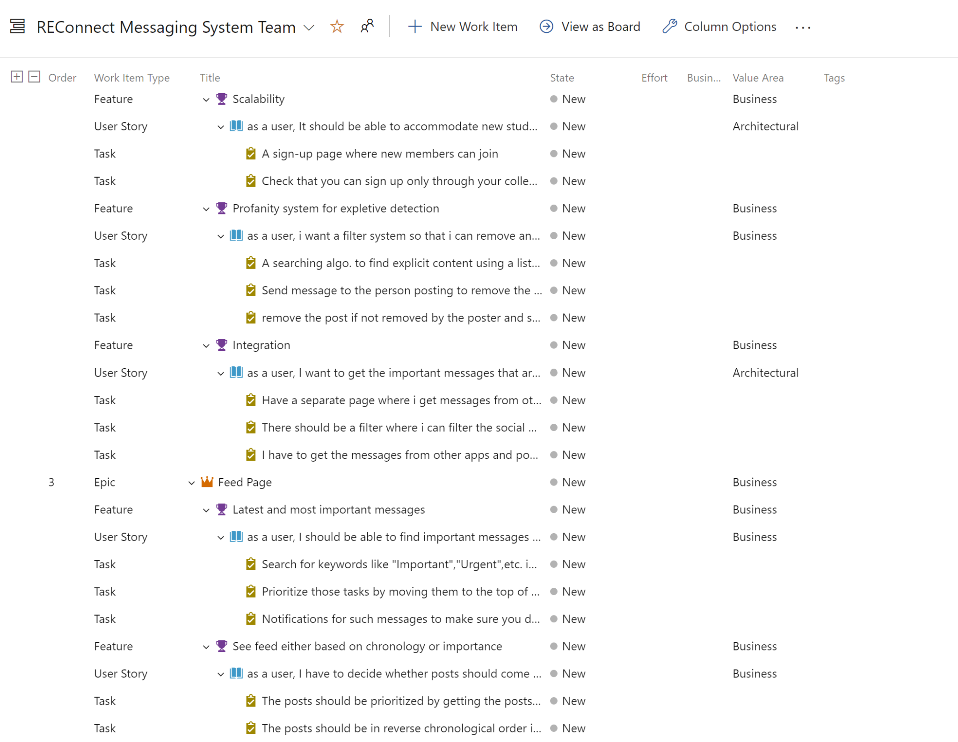

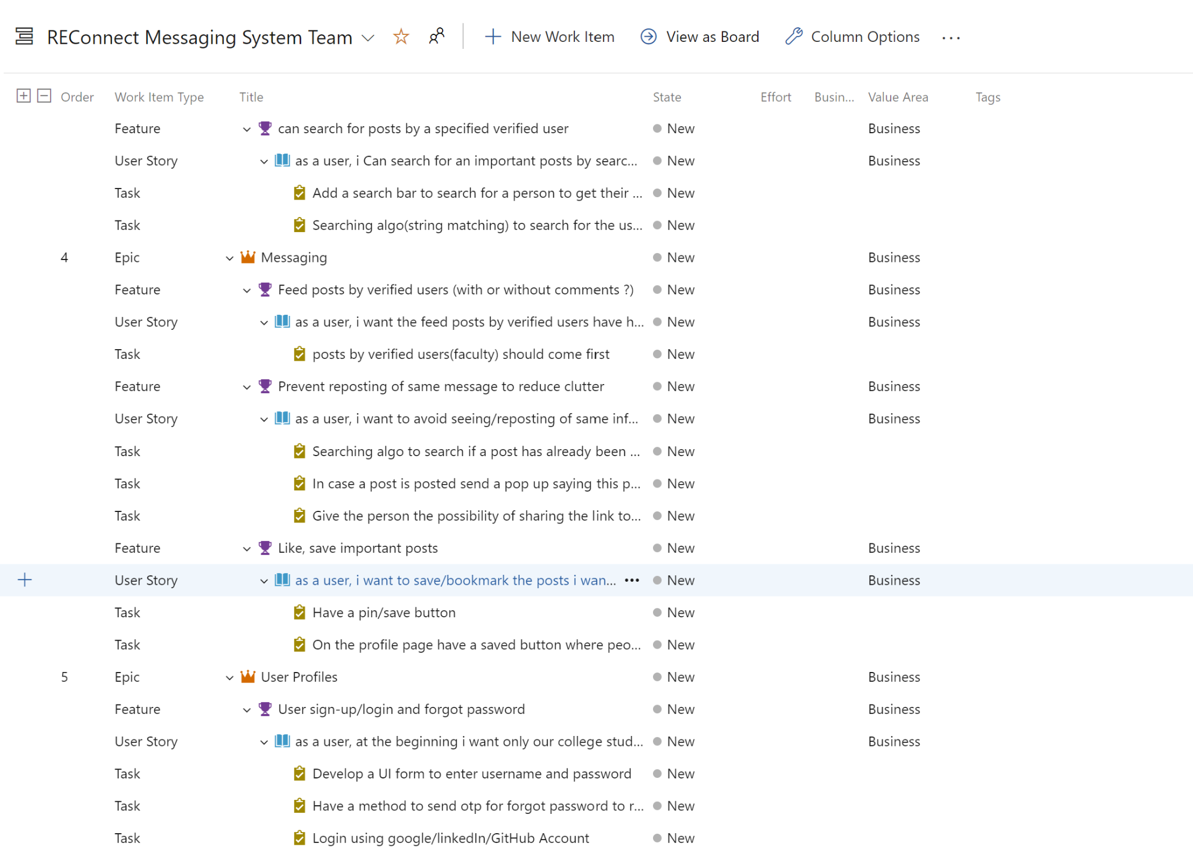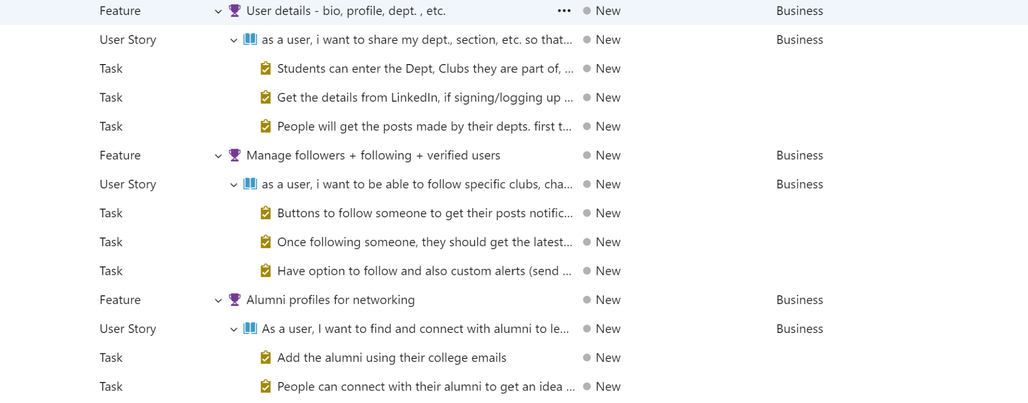

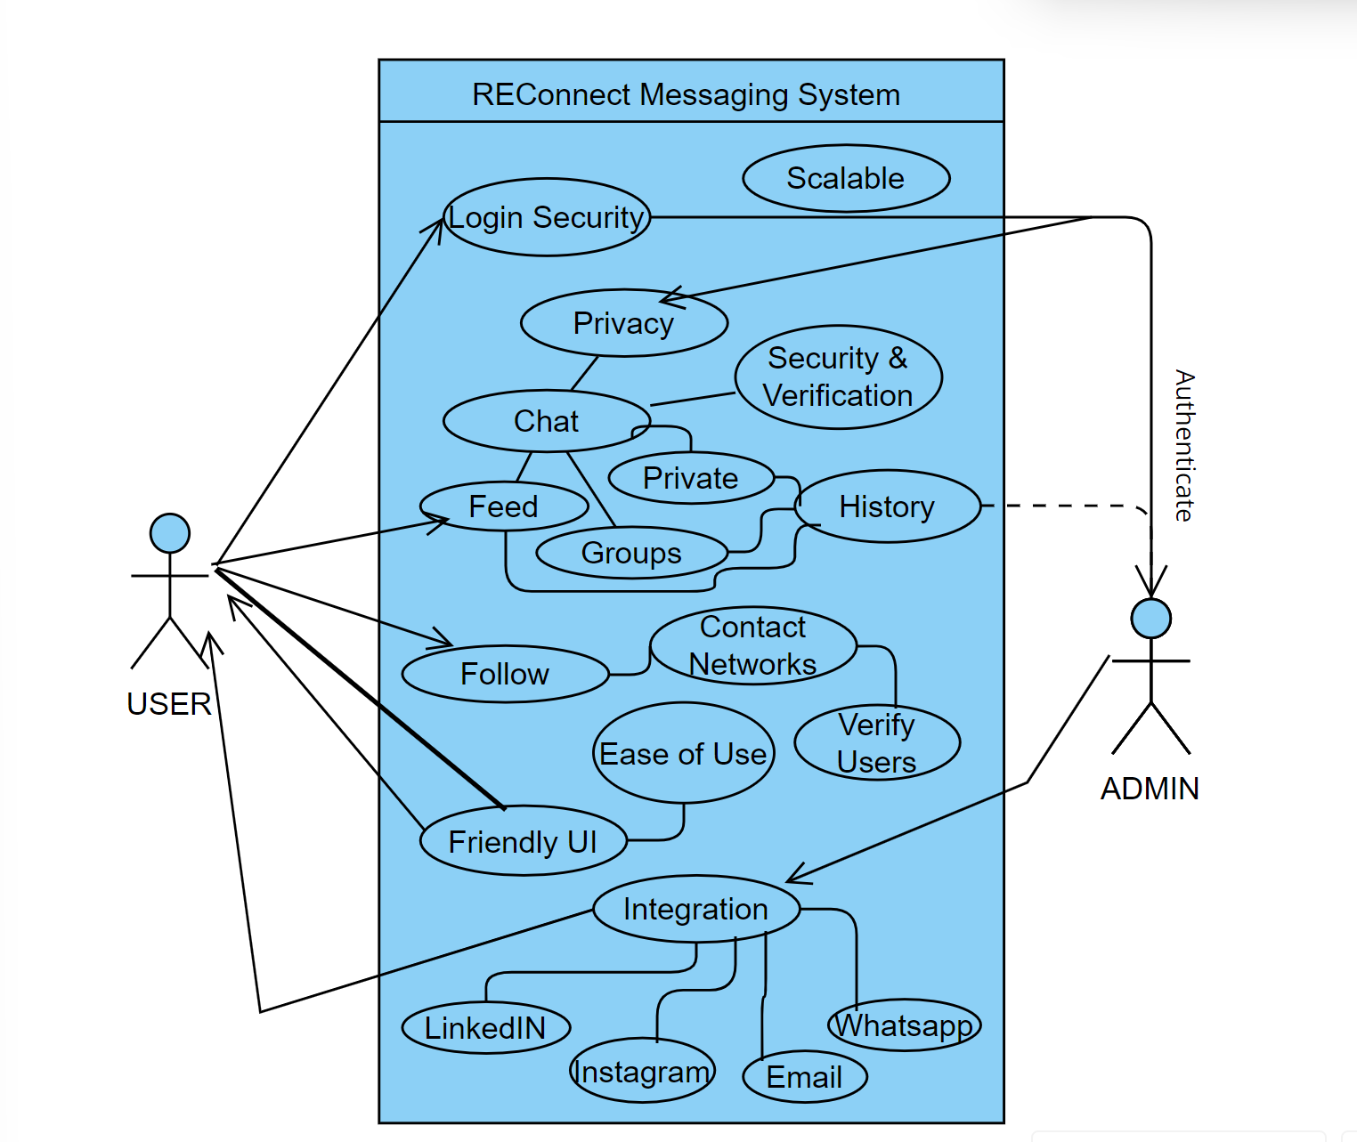

# Deployment Architecture of the application

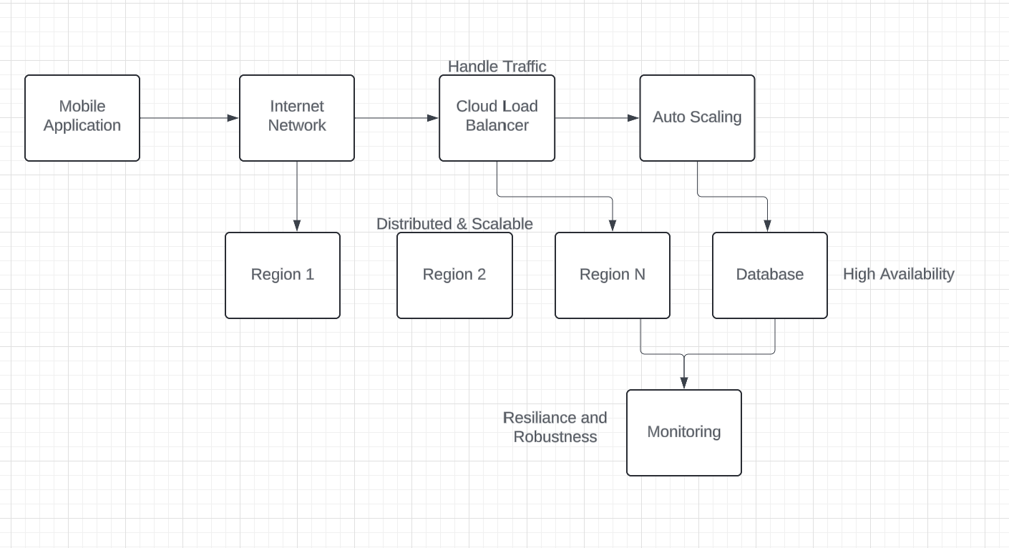

* **User Devices (Web/Mobile App):**Users interact with the application through their devices.
* **Internet:** Public network connection for users to access the application.
* **Cloud Load Balancer:** Distributes incoming traffic across multiple instances of the messaging system in different regions for optimal performance and scalability.
* **Auto Scaling:** These groups manage instances of your messaging system across different Availability Zones (AZs) within a cloud region. They automatically scale the number of instances up or down based on traffic demands.
* **Messaging System:** This represents the core application logic deployed across multiple instances within ASGs for redundancy and scalability.
* **Database:** A highly available database service deployed across multiple AZs within regions ensures data persistence and accessibility.
* **Monitoring:** Continuously monitors the health and performance of the messaging system and database, providing alerts and logs for troubleshooting and scaling decisions.

**Benefits of this Architecture**:

* High Availability
* Scalability
* Resilience
* Performance
* Observability